 | 26.10.12 Editors - Properties Editor - Particle Properties Tab - Emitter - Vertex Groups panel
Table of content
Vertex Groups panel 1
Density 1
Length 1
Clump 1
Kink 1
Roughness 1 1
Roughness 2 1
Roughness End 2
Twist 2

Vertex Groups panel
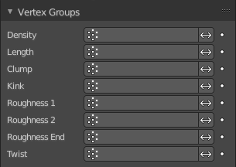
The Vertex groups panel allows you to specify vertex groups to use for several child particle settings. You can also negate the effect of each vertex group with the check boxes. You can affect the following attributes:

Density
Defines the density of the particle distribution.

Length
Defines the length of the hair.

Clump
Controls the amount of clumping. The weight of 1.0 gives current Clump value, weight of 0.0 completely removes effect.

Kink
Controls the frequency of the children Kink.

Roughness 1
Adjusts the Uniform roughness parameter.

Roughness 2
Adjusts the Random roughness parameter.

Roughness End
Adjusts the Endpoint roughness parameter.

Twist
Vertex group to control the children’s Twist effect. Gives control over the direction of the twist, as well as the amount. The weight of 0.5 is neutral, i.e. there is no twist effect.

